Tommaso Facchin
STA510 – Assignment 1 report

Problem 1

a) The pdf is valid because is non negative and integrate to 1.
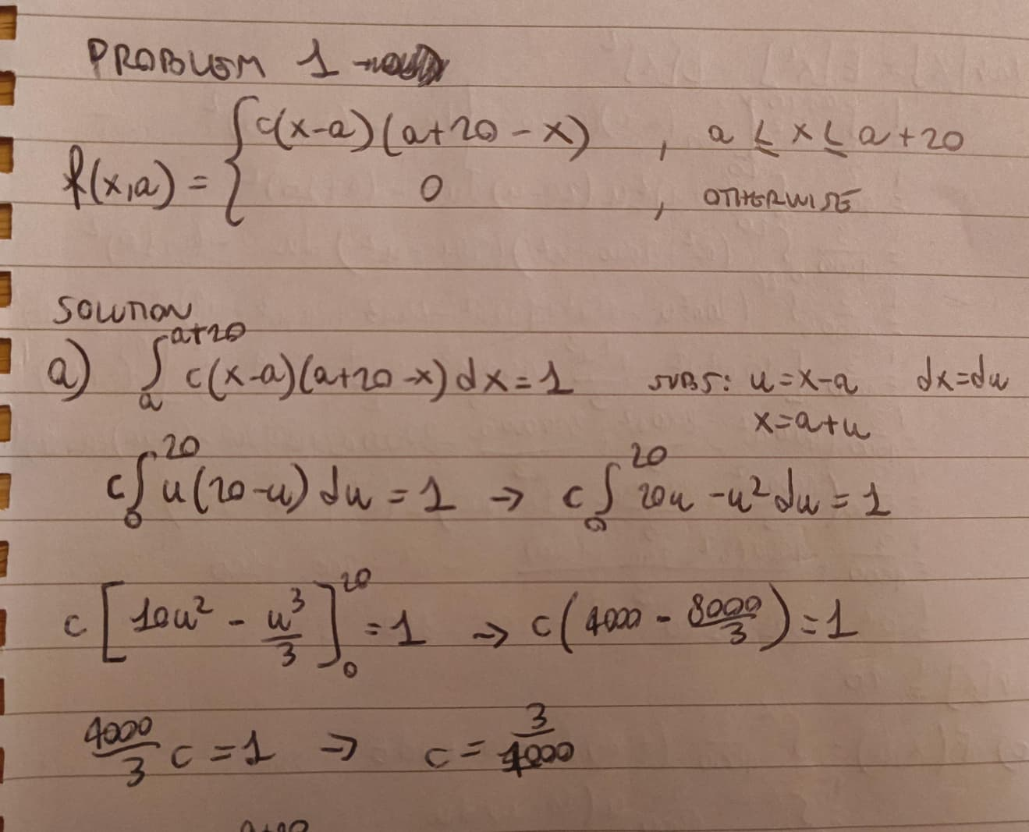

b)
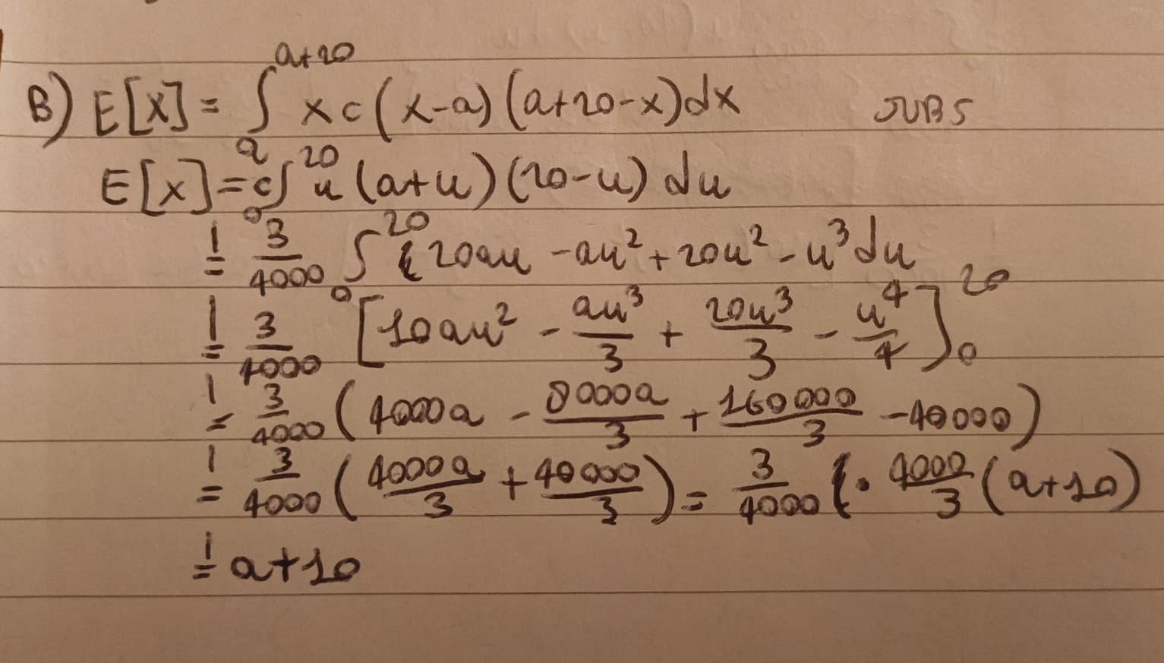

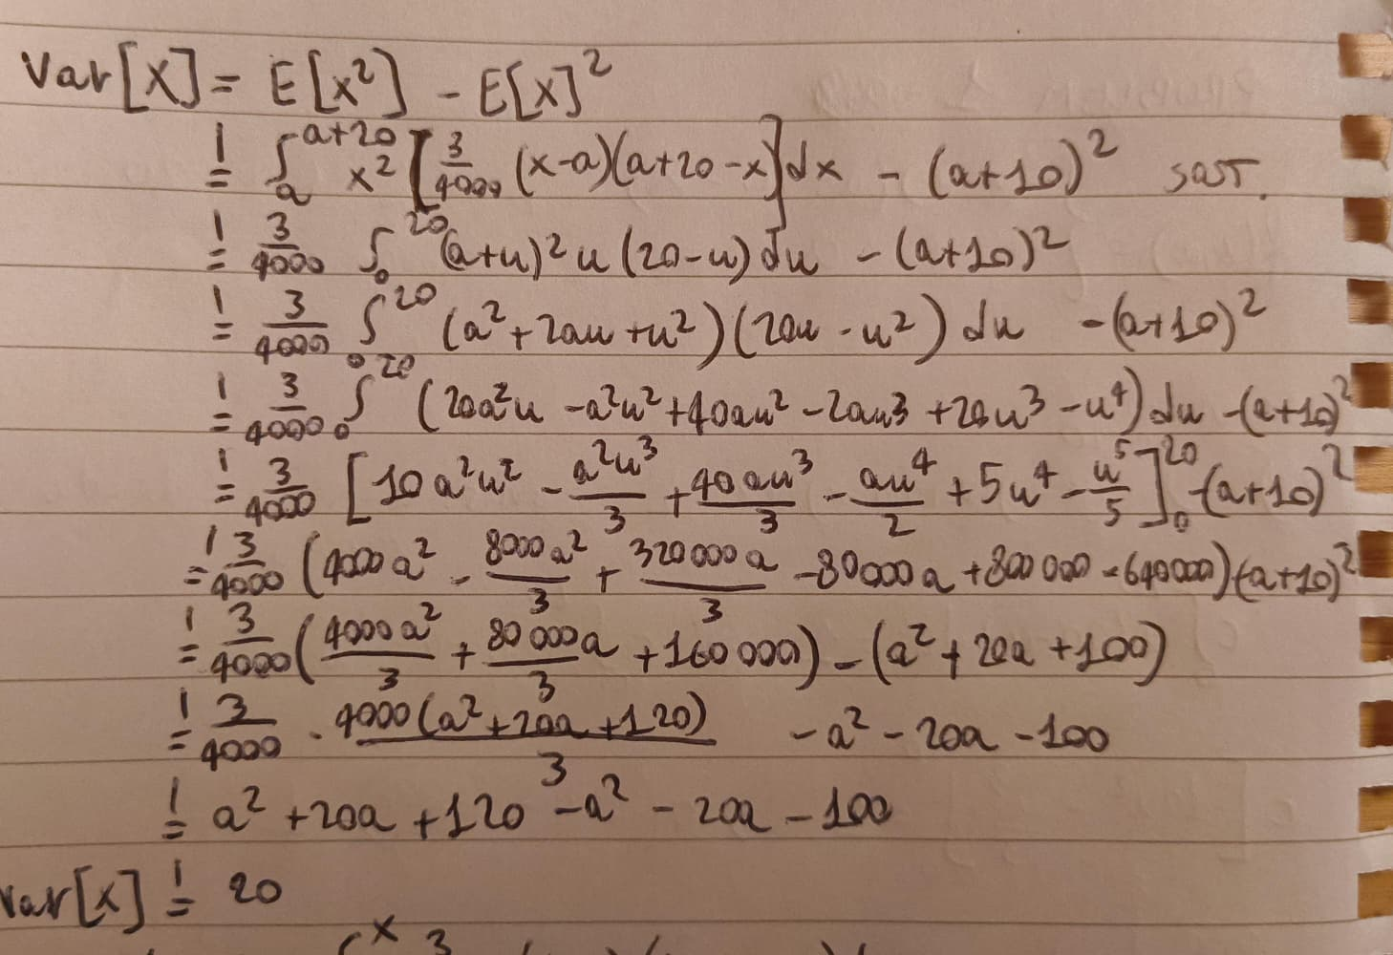

E[X] = a+10 means that a + 10m/s is the expected daily maximum wind speed during autumn. right in the middle of the minimum and maximum threshold.
Var[X] = 100 means that the daily maximum wind speeds have a spread around their expected value with standard deviation 10m/s.

c) Before a the density is 0. I used the same substitution.
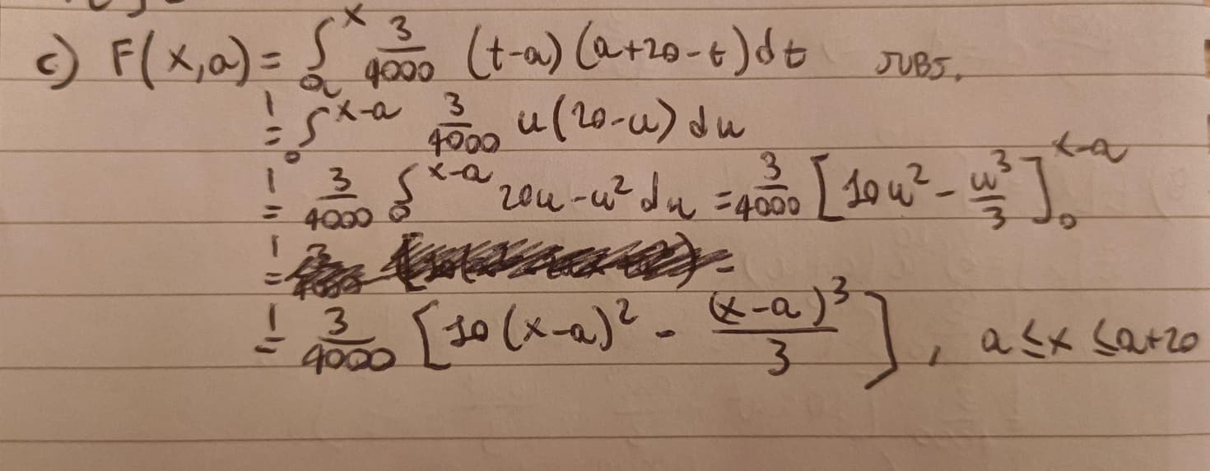
e)
- i) for finding M I used same substitution, and derivatives to find the maximum.
- ii) I calculated the acceptance probability. We generate a candidate Y from a uniform distribution U(a, a+20), then generate U from U(0,1) and accept Y if U is less than the calculated probability, otherwise reject. Repeat until we reach the desired number of sample.
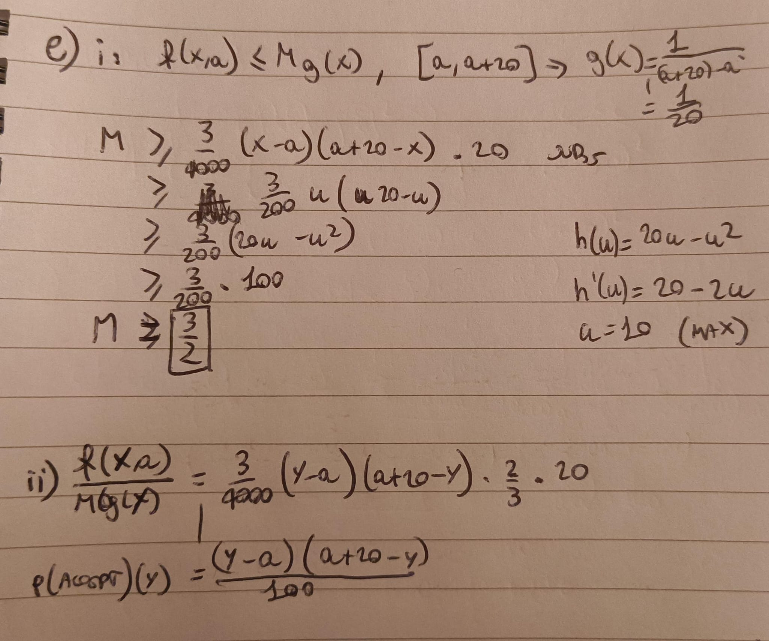

Problem 2

a) Calculated the log-likelihood, find the derivatives and set it = 0 to find the maximum, calculate the second derivatives to check whether the point is a maximum or a minimum, in this case it’s a maximum.
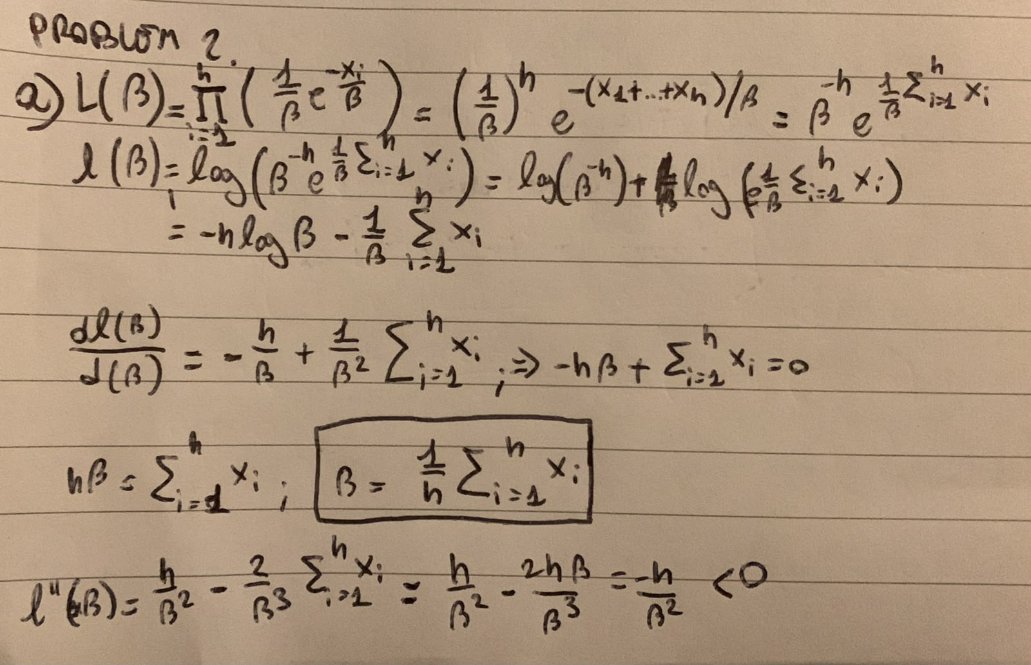

b) B hat is an unbiased estimator because E[B hat] = B
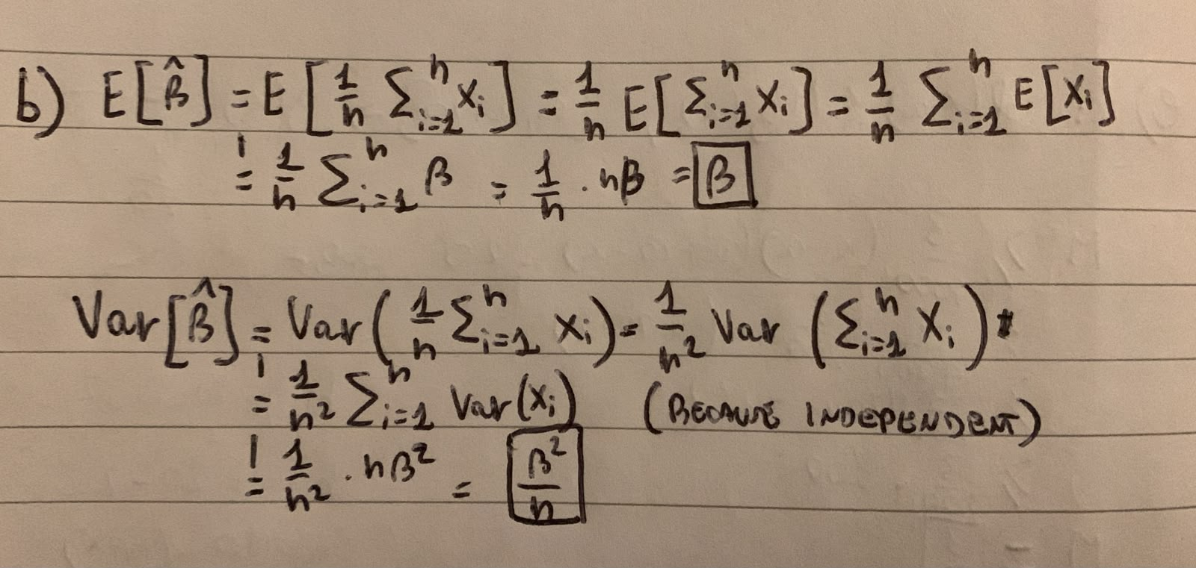

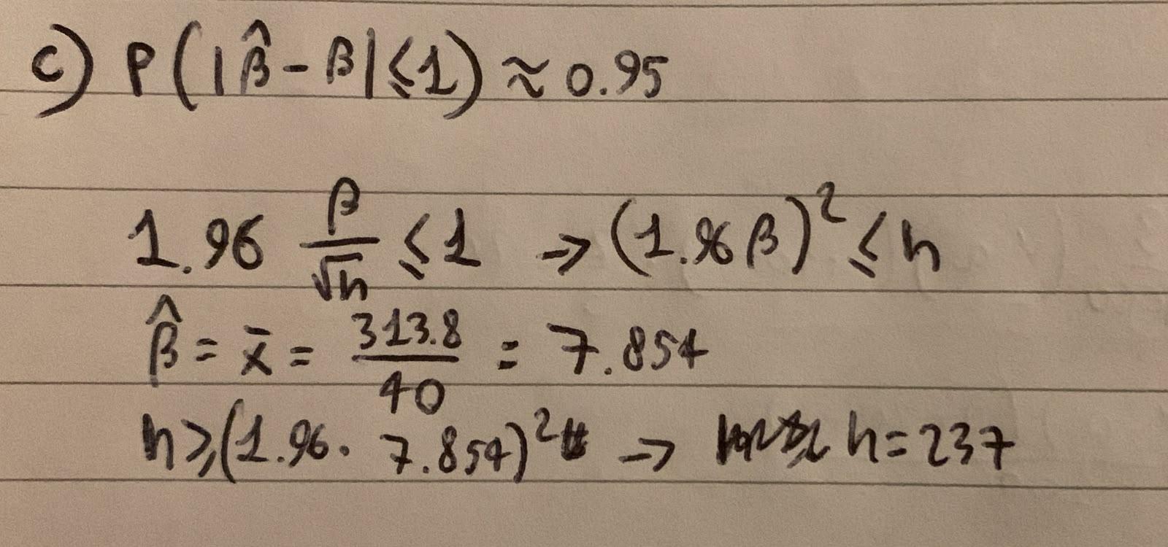
c) The CLT implies that for sufficiently large n, the sample mean is approximately normally distributed with mean B and sd B/sqrt(n).

Problem 3

c) No, the exponential distribution does not provide a good fit. It gives to much probability near the lowest values. A gamma distribution might be better, because the peak density can be different from zero.

Problem 4

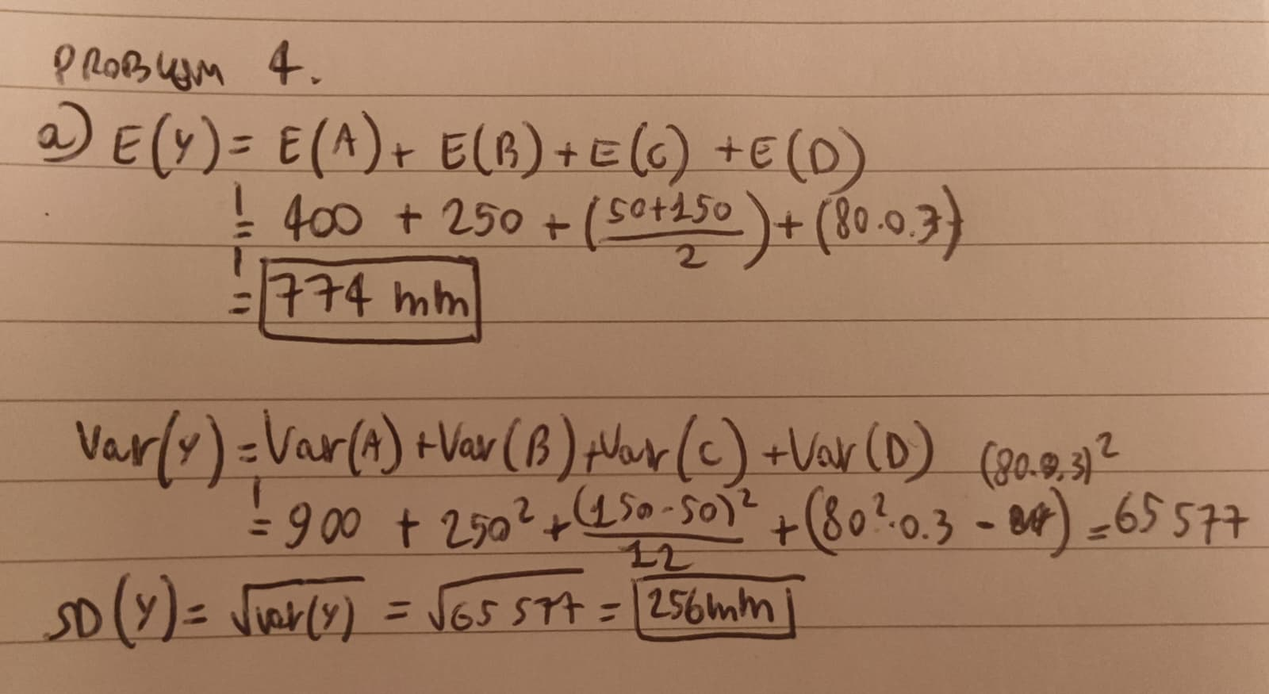
a) Expectations can just be summed together. The first two are given by the problem, the other two are easy to calculate. Because the sources are independent, the variance also add together. First is given, the other are easy to calculate.

